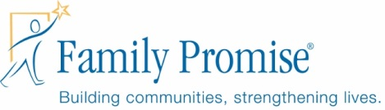

FOR IMMEDIATE RELEASE April 24, 2017

Contact:
JD Donnelly, Director, Family Promise-Salt Lake, 801-961-8622, jd@fpsl.org

Pets with a Promise Awards Grant to Family Promise-Salt Lake
Funding support from PetSmart Charities® helps keep families together with their pets.

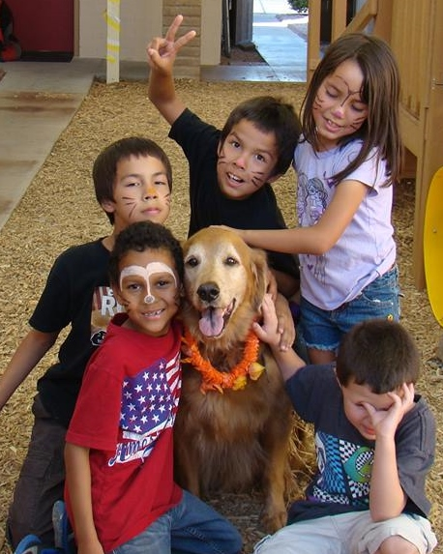
April 24, 2017-Salt Lake City— Family Promise-Salt Lake, an Affiliate of Family Promise, the nation’s leading nonprofit helping families experiencing homelessness, is proud to announce the launch of Pets with a Promise, which provides direct funding for Family Promise Affiliates nationwide for a variety of services, allowing families to keep their pets while working towards independence in the program.
Phoenix, Arizona.

The program launched with the help of a $150,000 grant from PetSmart Charities, the leading funder of animal welfare in North America, which will be disbursed in $2,500 increments to participating Family Promise Affiliates, including right here in Salt Lake City. The funds will allow Family Promise-Salt Lake to offer direct services to families with pets including boarding, vaccinations, veterinary care, pet supplies, and transportation related to boarding or fostering.

This program continues a five-year effort to address the heartbreaking choice that families often face when losing their homes—to seek shelter or to keep their beloved pet.

“This generous gift from Pets with a Promise ensures that families can retain their pets, and their dignity when they experience homelessness,” said JD Donnelly, Executive Director. “Our families are already dealing with a traumatic situation and providing an opportunity for families to keep their pets will alleviate any additional trauma.”

Family Promise National President Claas Ehlers said, “Just because children and their families lose their homes, they should not have to lose their pets. PetSmart Charities recognizes that its resources can prevent that additional trauma for families and keep the whole family—including its four-legged members—together. With their support and through the work of our 200+ Family Promise Affiliates, Pets with a Promise is an important part of a holistic, community-based approach to addressing family homelessness.”

Family Promise began working with PetSmart, Inc. in 2012 with the innovative PetSmart Promise program. On-site kennel facilities were built at Family Promise Day Centers nationwide to house guests’ pets. PetSmart also donated and installed aquariums to help teach the values and responsibilities of pet ownership, provided boarding space at PetsHotels, and created a fostering manual and network to house pets when on-site facilities were not available.

That program has been shifted to PetSmart Charites in 2017, but the mission remains the same—keeping families and their pets together.

“At PetSmart Charities, our mission is to find lifelong, loving homes for all pets by supporting programs and thought leadership that bring people and pets together,” said David Haworth, DVM, Ph.D., president of PetSmart Charities. “By working with organizations like Family Promise to support Pets with a Promise, we hope to create more resources for families with pets during difficult transitions and alleviate pet homelessness across the country.”

###
About Family Promise®
Family Promise was founded in 1988 on the belief that Americans are compassionate people who want to make a difference. Today, Family Promise comprises 203 Affiliates in 42 states, with more in development. Family Promise programs involve more than 180,000 volunteers and they provide comprehensive assistance to more than 50,000 family members annually. Since their founding, they have served more than 700,000 people, including tens of thousands of homeless families who found temporary homes at Affiliates nationwide. For the fourth consecutive year, Family Promise has been awarded four stars from Charity Navigator, their highest rating, for sound fiscal management and commitment to accountability and transparency.

Family Promise-Salty Lake is an interfaith alliance helping families experiencing homelessness achieve lasting self-sufficiency. Since 1995, our unique and unduplicated shelter model has mobilized the faith community to combat family homelessness in Salt Lake, serving over 800 families, with more than 300,000 volunteer hours! Family Promise-Salt Lake is unique in its approach to ending homelessness--and it’s working. 91% of families who complete our program remain housed after 2 years and do not return to homelessness.

About PetSmart Charities®
PetSmart Charities, Inc. is a nonprofit animal welfare organization with a mission to find lifelong, loving homes for all pets by supporting programs and thought leadership that bring people and pets together. In addition to finding homes for almost 500,000 shelter pets each year through its in-store adoption program in all PetSmart stores across the U.S. and Puerto Rico, PetSmart Charities provides funding to non-profits aligned with its mission through four key areas of grant support: Preventing Pet Homelessness; Helping Shelter Pets Thrive; Supporting the Bond Between People and Pets; and Emergency Relief and Disaster Support. Each year, millions of generous PetSmart shoppers help pets in need by donating to PetSmart Charities using the pin pads at checkout registers inside PetSmart stores. In turn, PetSmart Charities efficiently uses 90 cents of every dollar donated and has become the leading funder of animal welfare in North America, donating about $300 million to date. PetSmart Charities, a 501(c)(3) organization, has received the Four Star Rating from Charity Navigator, an independent organization that reports on the effectiveness, accountability and transparency of nonprofits, for the past 14 years in a row -- placing it among the top one percent of charities rated by this organization. To learn more visit www.petsmartcharities.org.

